***Git Assignment***

**1.Create a directory ‘project_dir’ & cd to ‘project_dir’.**

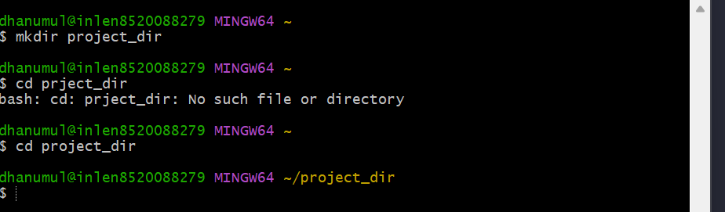

**2.Initialize git version database.(git init)**

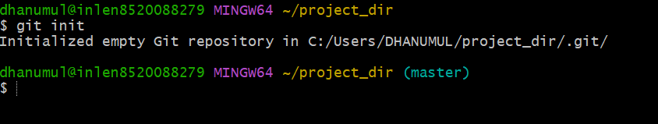

**3.Create a new file index.html.**

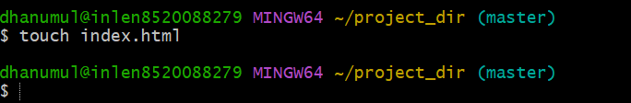

**4.Check the git status. You should find index.html as untracked file.**

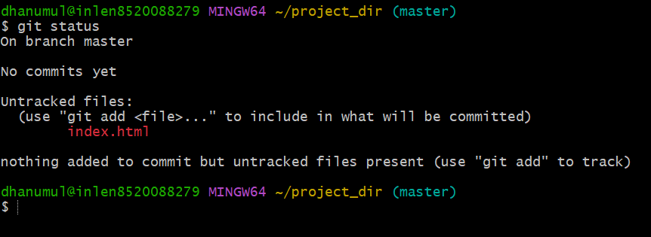

**5.Stage the index.html file.**

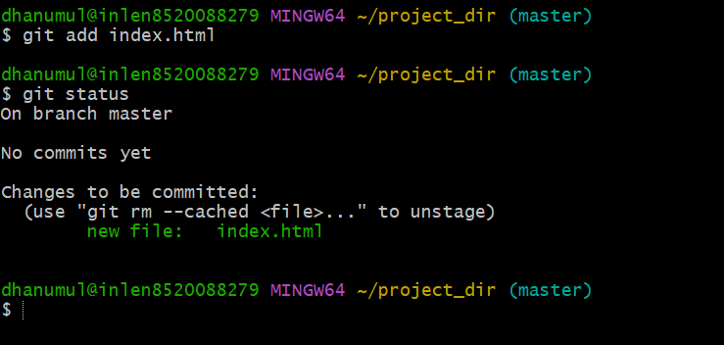

**6.Commit index.html**

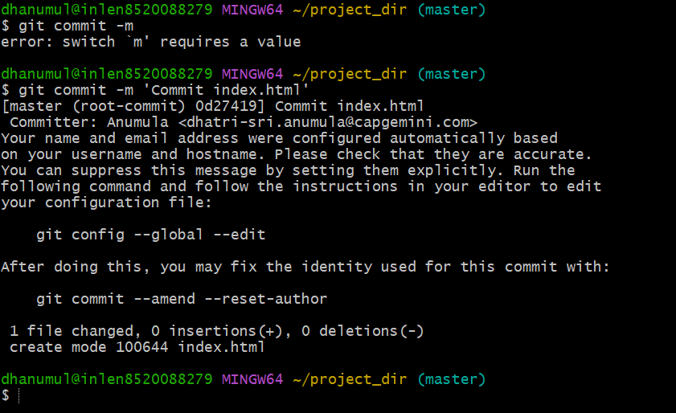

**7.Make few changes in index.html & create a new file info.txt file.**

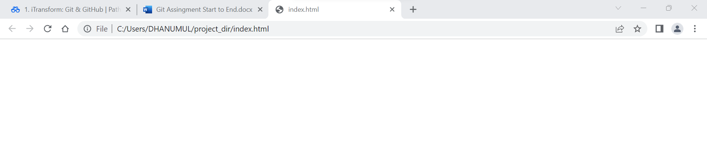

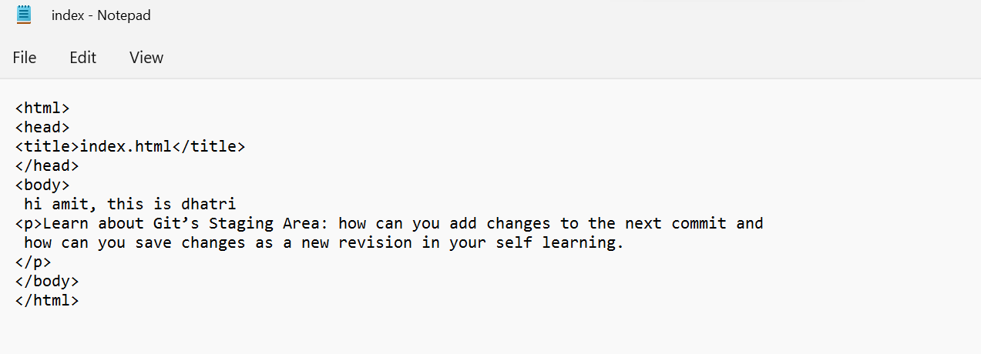

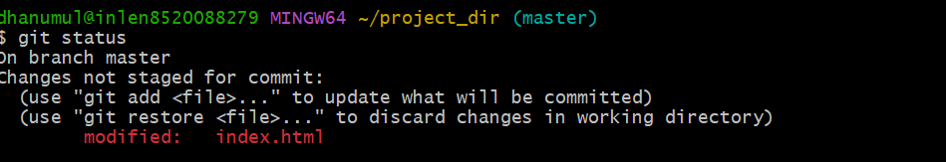

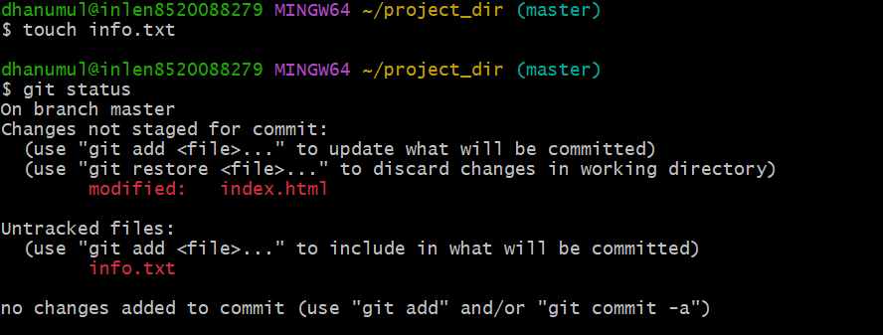

**8.Check git status. You should find index.html & info.txt.file**

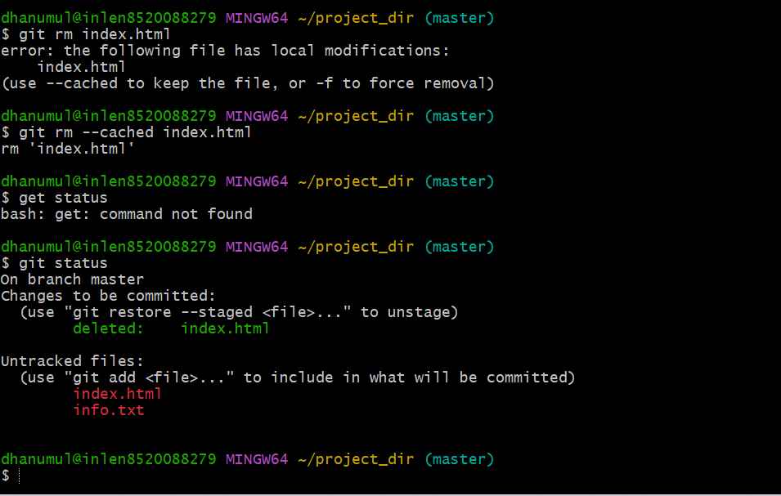

**9.Configure GIT to ignore all txt files.**

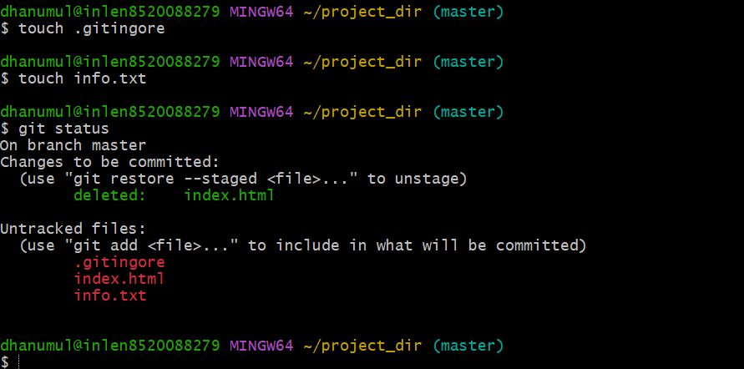

**10.Again check the git status. You should find only index.html as untracked file**

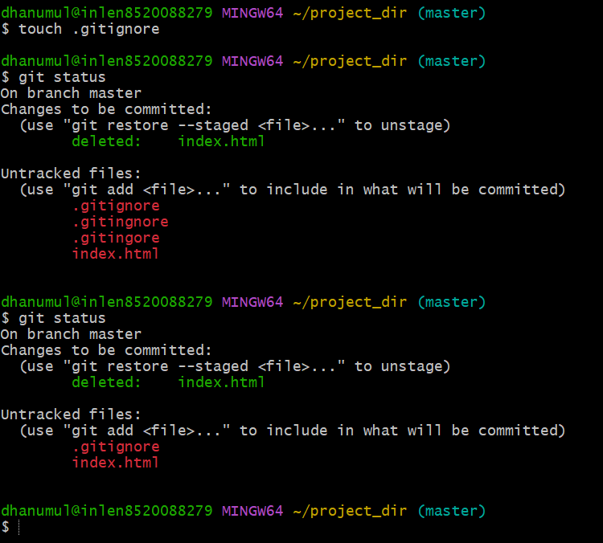

**11.State & commit index.html**

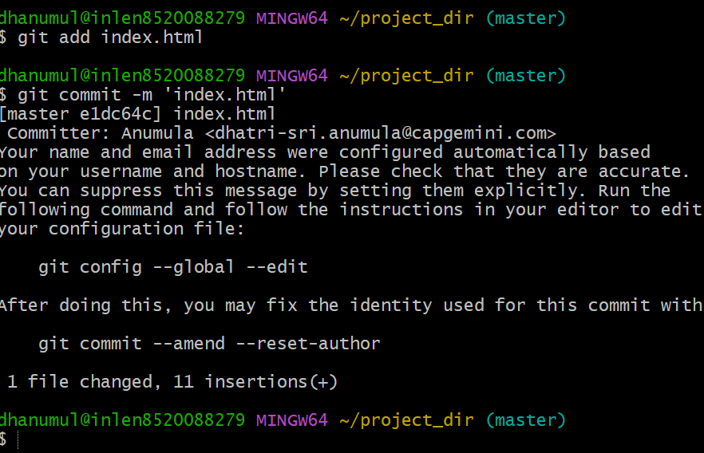

**12.Log all your comments so far.**

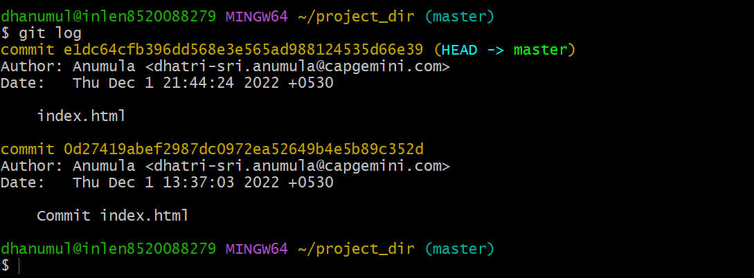

**13.Make some changes in index.html**

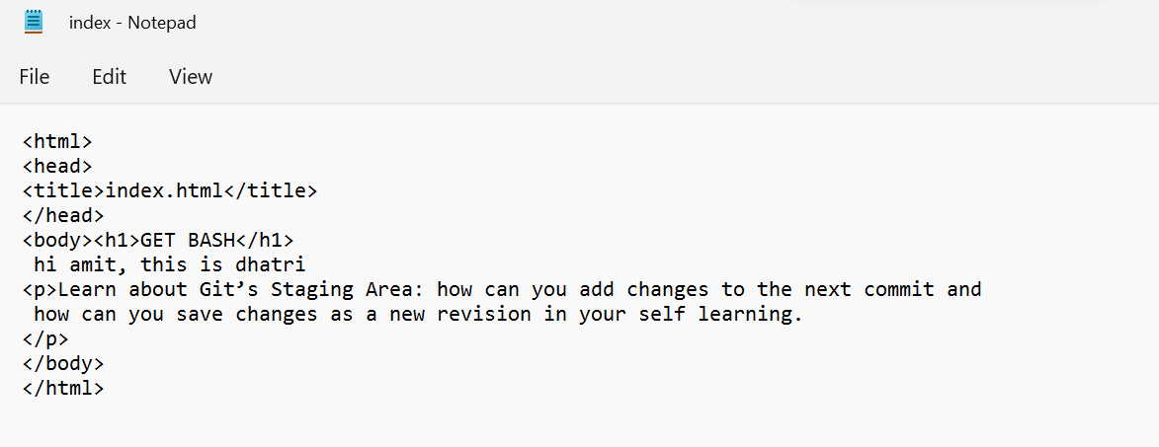

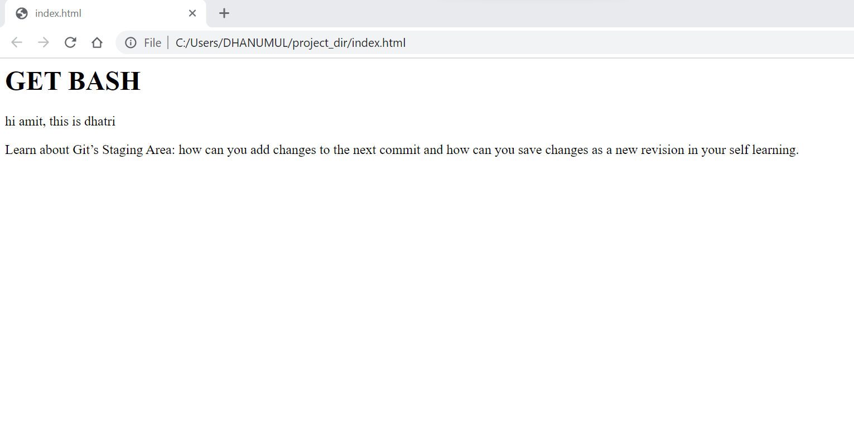

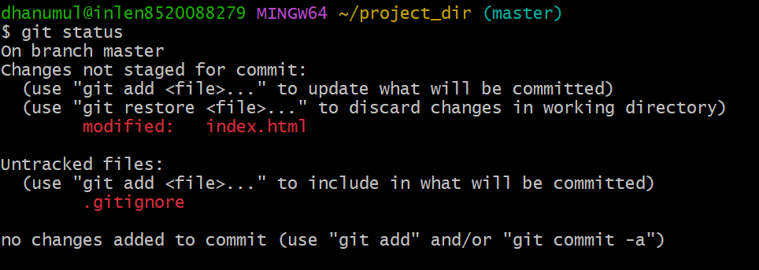

**14.Revert the change made in the previous step using git command.**

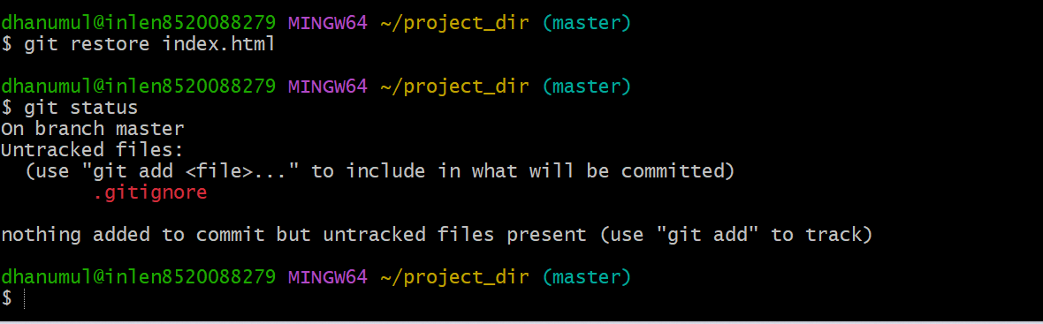

**15.Again change index.html.**

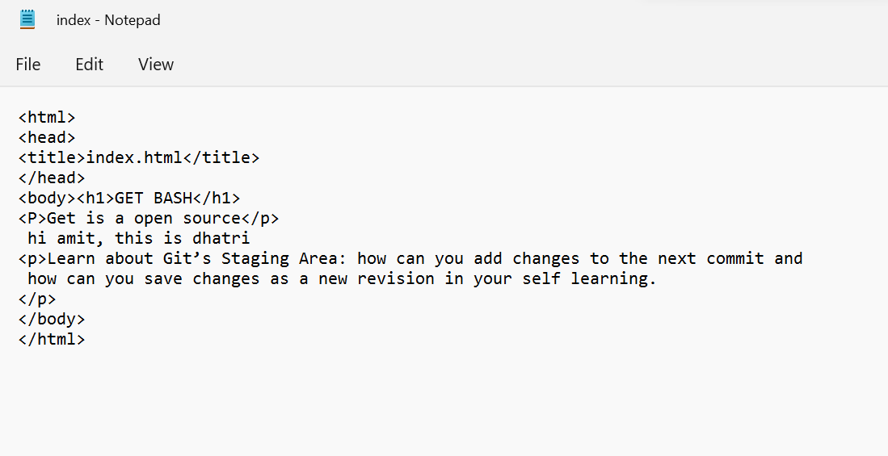

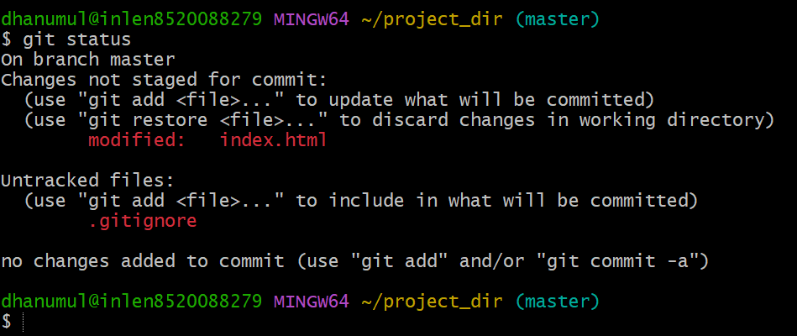

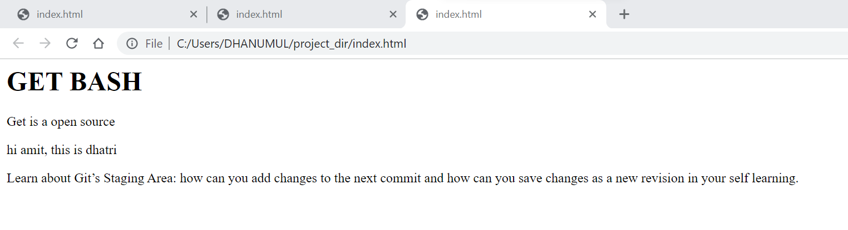

**16.stage index.html**

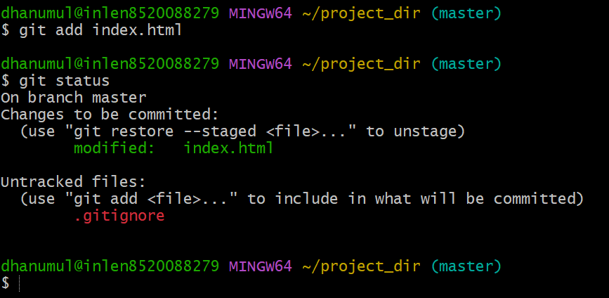

**17.Revert back the last stage.**

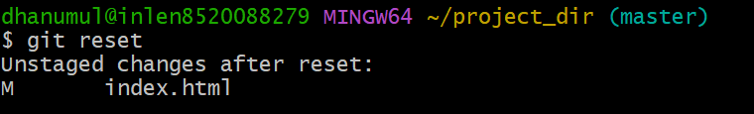

**18.Rename ‘add’ command to ‘my -add’**

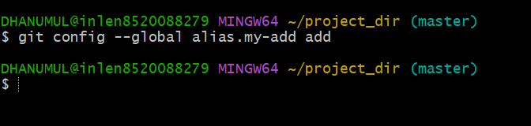

**19.Using my add command stage index.html again & commit the changes.**

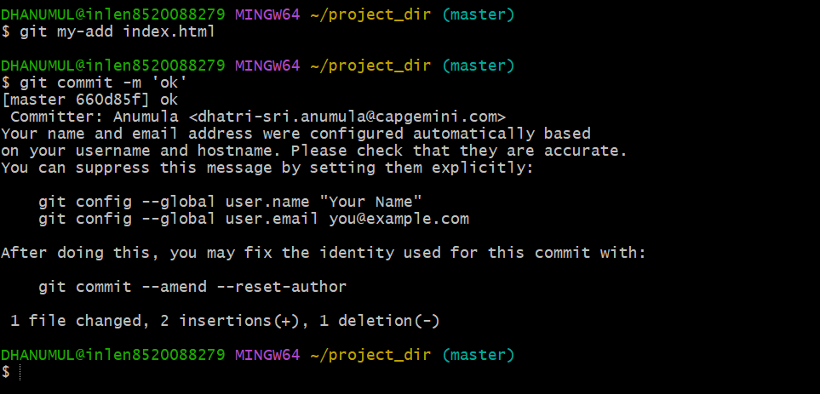

**20.Revert the last commit.**

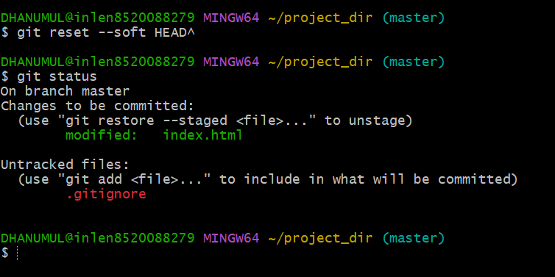

**GIT BRANCHING**

**21.First take a backup of your assignments & projects. This is required because due to incorrect Git operation you may lose your Files.**

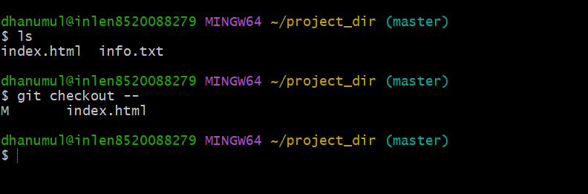

**22. create an empty directory ‘assignment’ &cd to ‘assignment’.**

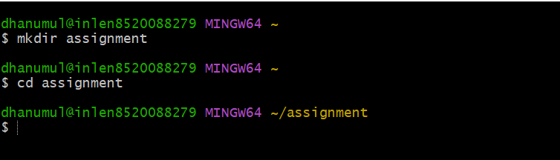

**23.Create a file README.txt inside ‘assignments’ & write few lines about the contents of ‘assignments’ folder**

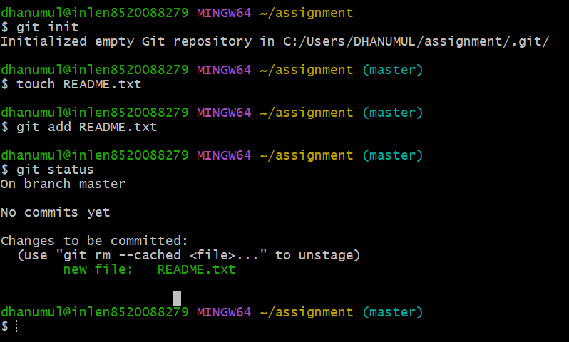

**24. Commit README.txt file**

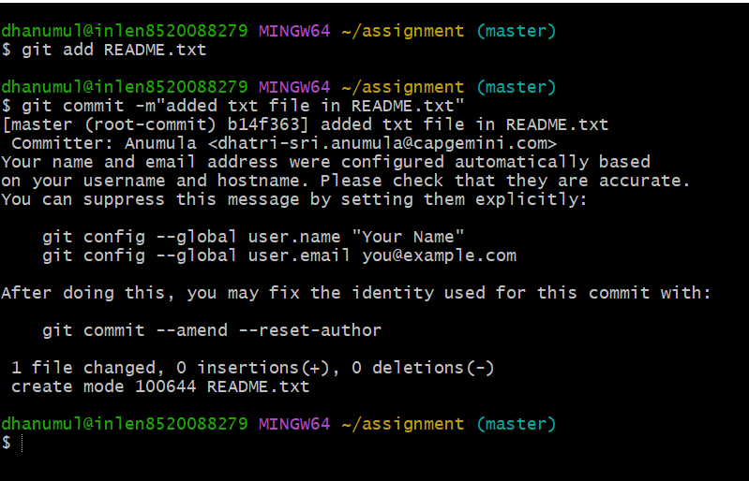

**25.Now create a new branch ‘html-assignment’.**

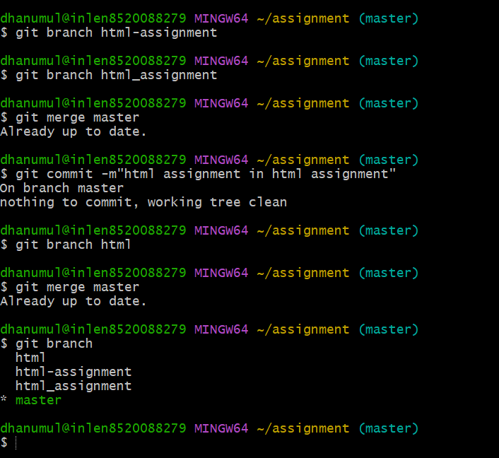

**26.switch to ‘html-assignment’ branch**

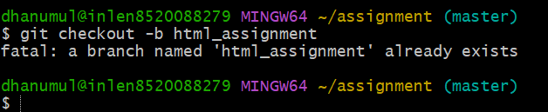

**27. copy all html assignment inside ‘assignment’ folder.**

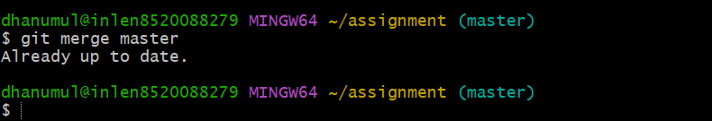

**28. Commit html assignment into ‘html-assignment’ branch**

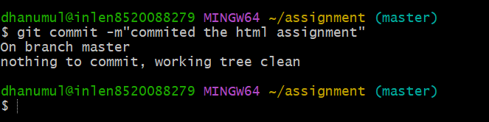

**29. make minor changes into few files belonging to ‘html-assignment’ branch.**

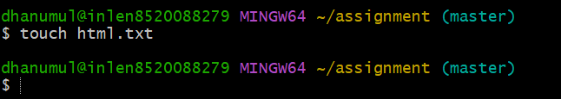

**30.Switch to master branch.**

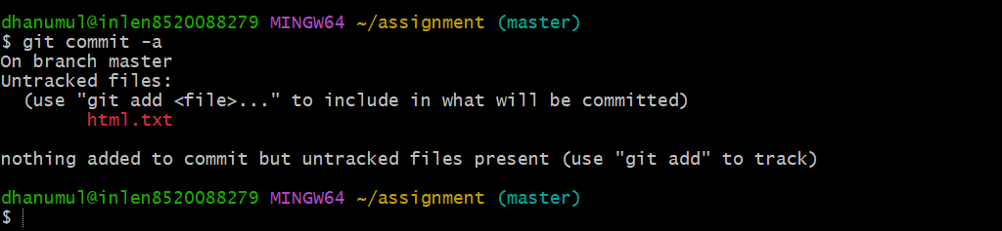

**31.Switch to master branch**

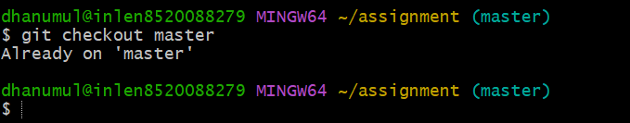

**33.Again switch to ‘html-assignment’ branch**

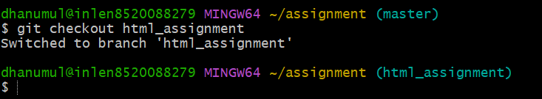

**34.make minor changes into few files belonging to ‘html-assignment’ branch.**

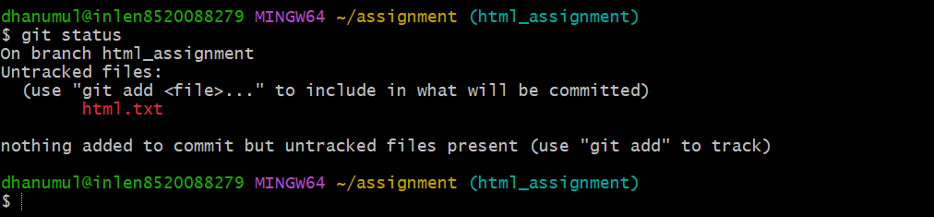

**35. Commit those changes**

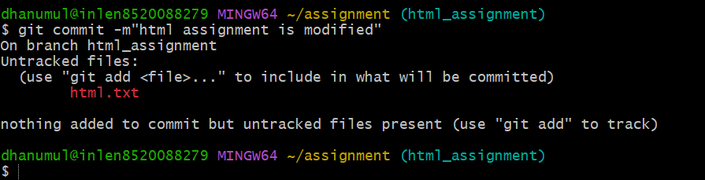

**36.Switch to master.**

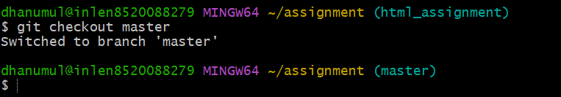

**37.Merge ‘html-assignment’ branch into master. Confirm all html assignments are shown in master.**

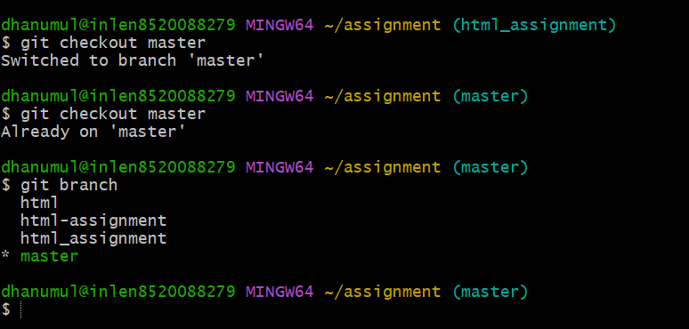

**38.Finally delete the ‘html-assignment’ branch.**

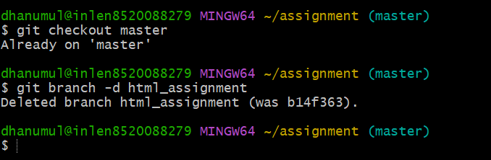

**CSS Assignment**

**39. Create a new branch ‘css – assignment’.**

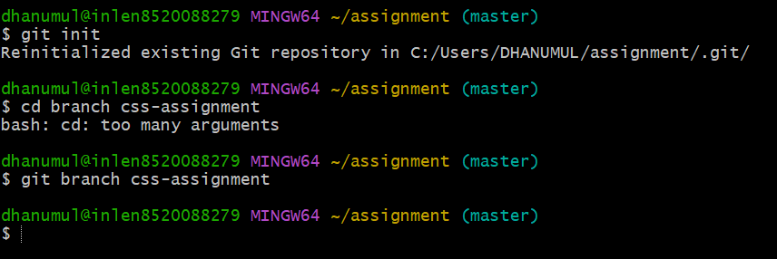

**40.Switch to ‘css-assignment’ branch.**

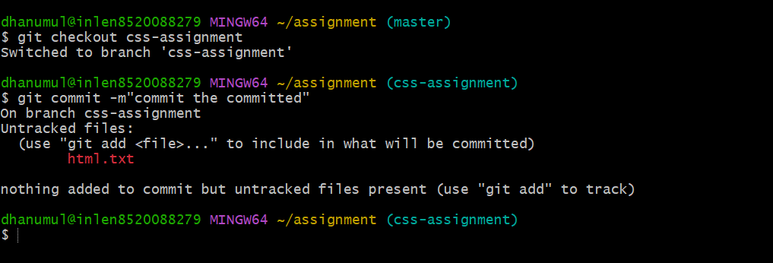

**42.Copy all css assignments into ‘assignment’branch.**

